Assignment 5 - Retrieving Data from Multiple Tables

Part 1: What are the sales for a particular item?

A.  
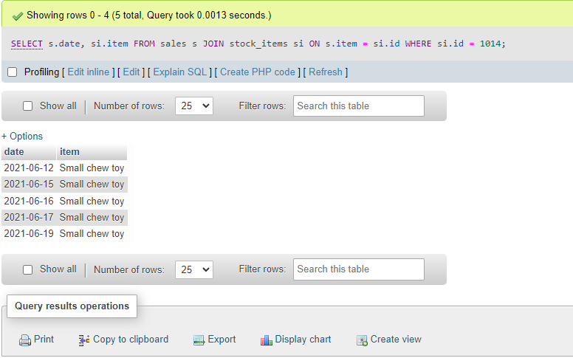

B.  
  
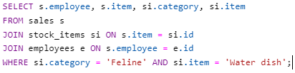  
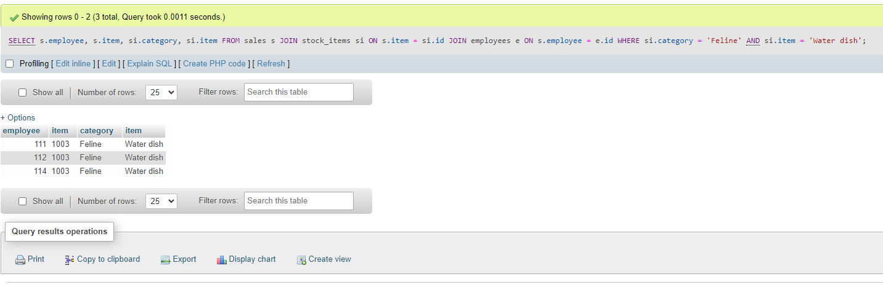

Part 2: What are the sales for a particular team member?

A.  
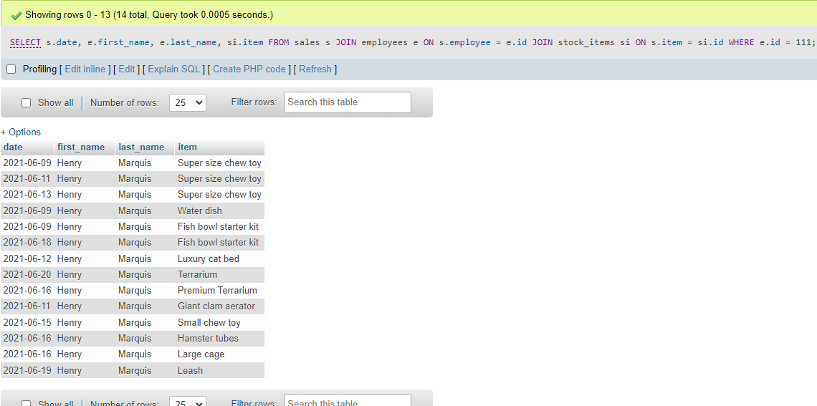

B.  
  
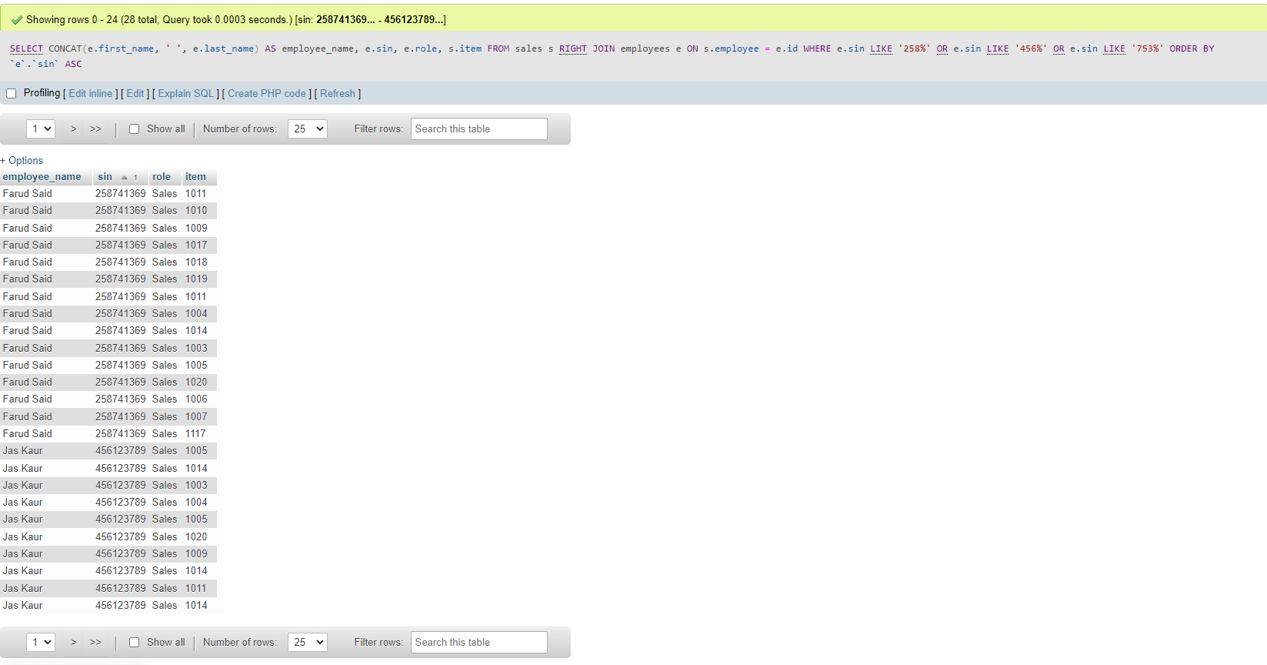  
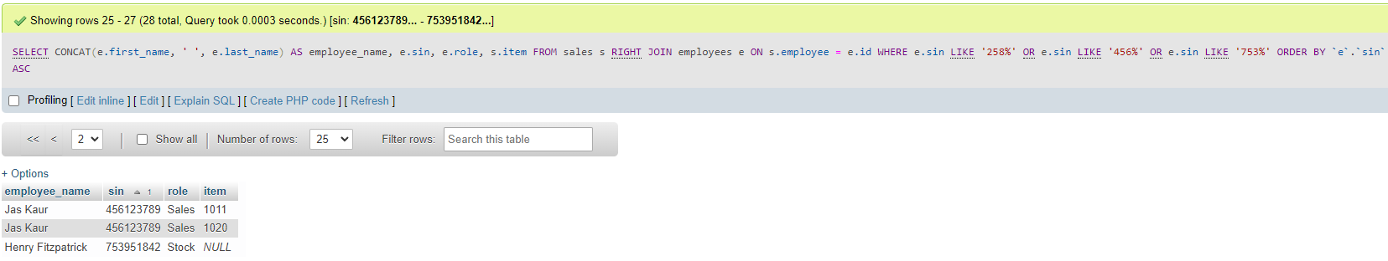

Part 3: What a week! and Go Team!

A.

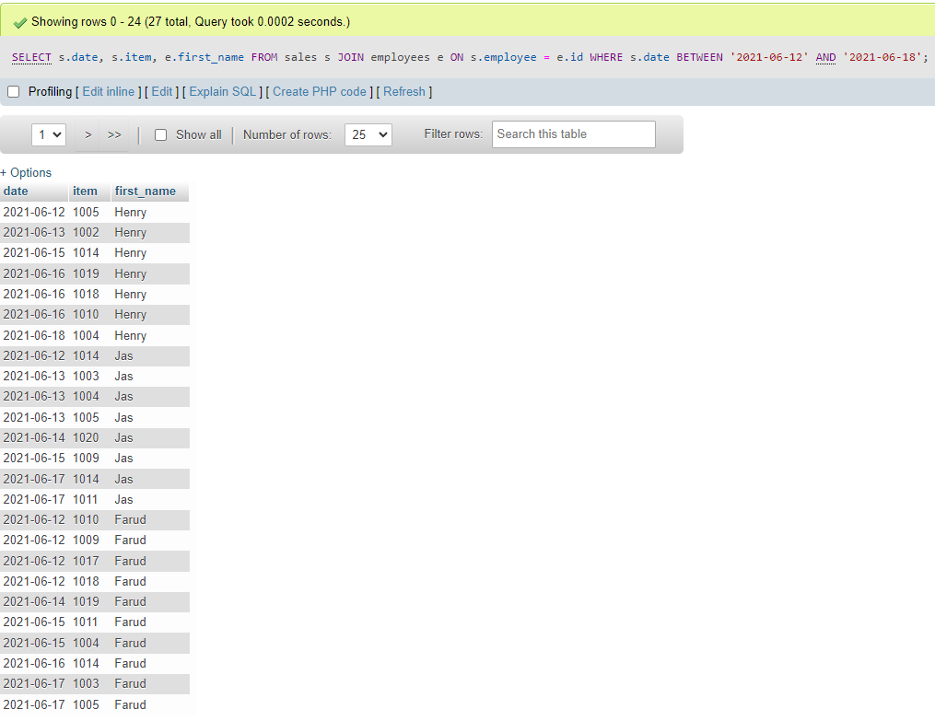

B.

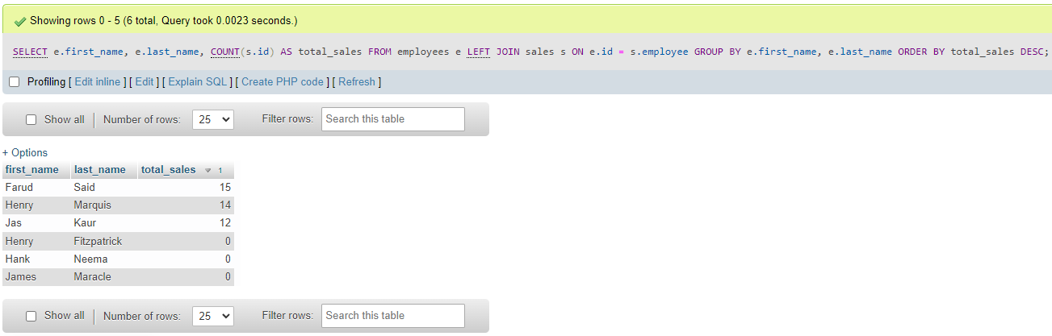

Part 4: Challenge

A.

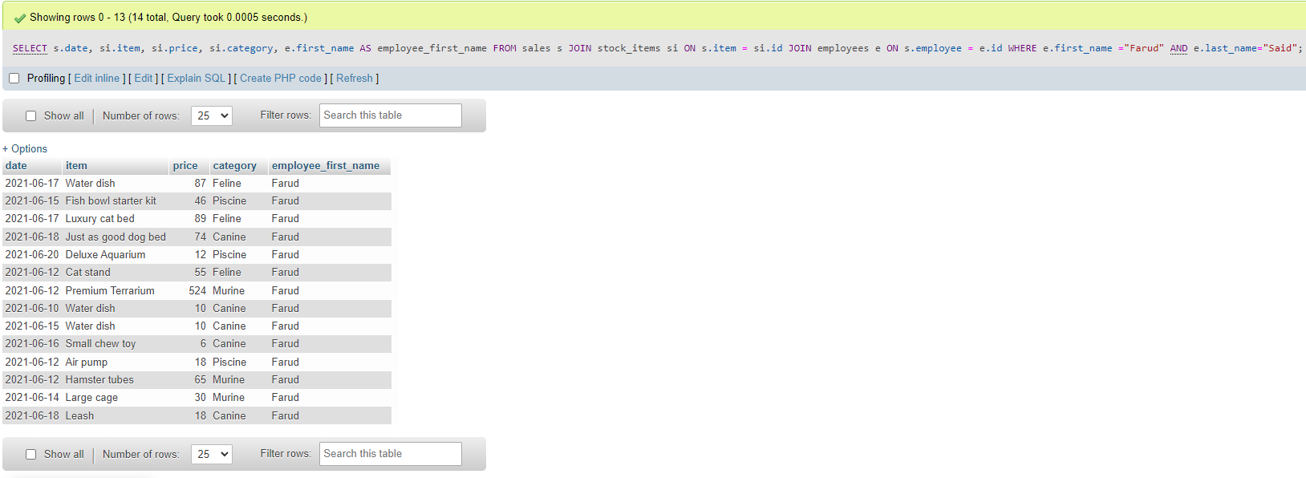

B.  
